PathSimR – Stroke Reconfiguration Example

# Problem

## Project title & summary

**Capacity modelling to support stroke reconfiguration**

This example pathway is based on ongoing work by BNSSG CCG to investigate the reconfiguration of the acute stroke care pathway across the sub-region, including theoretical results published by the CCG’s Modelling and Analytics team.[1] The numbers used in this example are illustrative of the problem and do not represent actual values.

## Key questions & insights

* Number of beds required in both HASU and ASU wards so that the probability of a patient arriving and finding HASU full is <1%.

## Key PathSimR Features

* Includes both Capacity Driven Delays & Transition Departure Delays (to exits)
* Infinite queue for external arrivals to a unit. This could be changed to a zero queue length to investigate different dynamics in the system.
* Zero length internal queues to replicate continuous bedded care across multiple service points.

## Summary of services along patient pathway

|  |  |  |
| --- | --- | --- |
| Service Point | Service Point Type | Description |
| Hyper Acute Stroke Unit (HASU) | Continuous care bedded ward | * # of beds to be determined by analysis (initial estimate = 40) * Number of beds is fixed throughout the year * LOS: 3.3 days (exponential with rate = 0.3030) |
| Acute Stroke Unit (ASU) | Continuous care bedded ward | * # of beds to be determined by analysis (initial estimate = 35) * Number of beds is fixed throughout the year * LOS: 7.7 days (exponential with rate = 0.13) |
| Subacute 1  (SA1) | Continuous care bedded ward | * # of beds to be determined by analysis * (initial estimate = 20) * Number of beds is fixed throughout the year * LOS: 24 days (exponential with rate = 0.0417) |
| Subacute 2  (SA2) | Continuous care bedded ward | * # of beds to be determined by analysis * (initial estimate = 20) * Number of beds is fixed throughout the year * LOS: 24 days (exponential with rate = 0.0417) |

## Summary of exits from patient pathway

|  |  |  |
| --- | --- | --- |
| Exit | Possible Discharge Delay | Description |
| Home | 0.5 day delay | No care or rehab needs |
| Home & ESD (Early Supported Discharge) | 1.5 days delay |  |
| Stroke repat | 2 day delay |  |
| Simple (1&2) | 1.5 days | Represents a grouping of lower delay exits |
| Complex (1&2) | 2 days | Represents a grouping of higher delay exits |
| Mimics | N/A |  |
| Mortality | N/A |  |

## External arrival rates to the patient pathway and queue capacity

|  |  |  |
| --- | --- | --- |
| Service Point | Arrival Rate Estimation | Queue Capacity |
| Hyper Acute Stroke Unit (HASU) | 5.14/day (exponential distn) | **External:** 9999  **Internal:** 0 |
| Acute Stroke Unit (ASU) | N/A | **External:** 0  **Internal:** 0 |
| Subacute 1  (SA1) | N/A | **External:** 0  **Internal:** 0 |
| Subacute 2  (SA2) |  |  |

## Features of the patient pathway

***Please provide a brief overview of how the services are connected within the pathways and where patients can exit to. It may be helpful to provide an initial sketch of the network in parts or whole. An estimation of the percentage of patients that move between each service point would also be helpful. Also indicate any special rules that may apply within these service points or the queues connecting them.***

|  |  |  |
| --- | --- | --- |
| Service Point | Onward Service Points or Exits | Additional Information |
| Hyper Acute Stroke Unit (HASU) | ASU – 42%  Mimics – 25%  Home – 15%  Home & ESD – 7.5%  Stroke repat – 3%  Mortality – 7.5% |  |
| Acute Stroke Unit (ASU) | Subacute 1 – 35%  Subacute 2 – 22.5%  Stroke repat – 2%  Home – 9%  Home & ESD – 27%  Mortality – 4.5% |  |
| Subacute 1  (SA1) | Complex 1 – 71%  Simple 1 – 29% |  |
| Subacute 2  (SA2) | Complex 2 – 71%  Simple 2 – 29% |  |

## Assumptions and limitations

***Please provide a brief overview of any assumptions made in the description above and any limitations that the model may not be able to accurately simulate.***

* The model assumes an infinitely large queue can grow at the front of the HASU unit. This is in order to enforce a realistic arrival rate. If the queue was removed then an outcome of the model would be that patients may be lost from the system upon arrival. In reality, patients would wait (typically in A&E) for a limited amount of time before either being admitted or being outlied in a different department. The purpose letting the queue form in this model was to estimate the capacity required to constrain it to an acceptable size while also satisfying downstream performance measures.

# Inputs

## Pathway Figure

Entering the pathway information above into the PathSimR Pathway Wizard, a set of model inputs and a pathway visualisation were automatically created. The pathway diagram (a static version of the tool output is presented in figure 1) serves as a sense check on whether the inputs have been entered correctly, and can inform discussion about what parameters or service point configurations might be varied in what-if analysis.

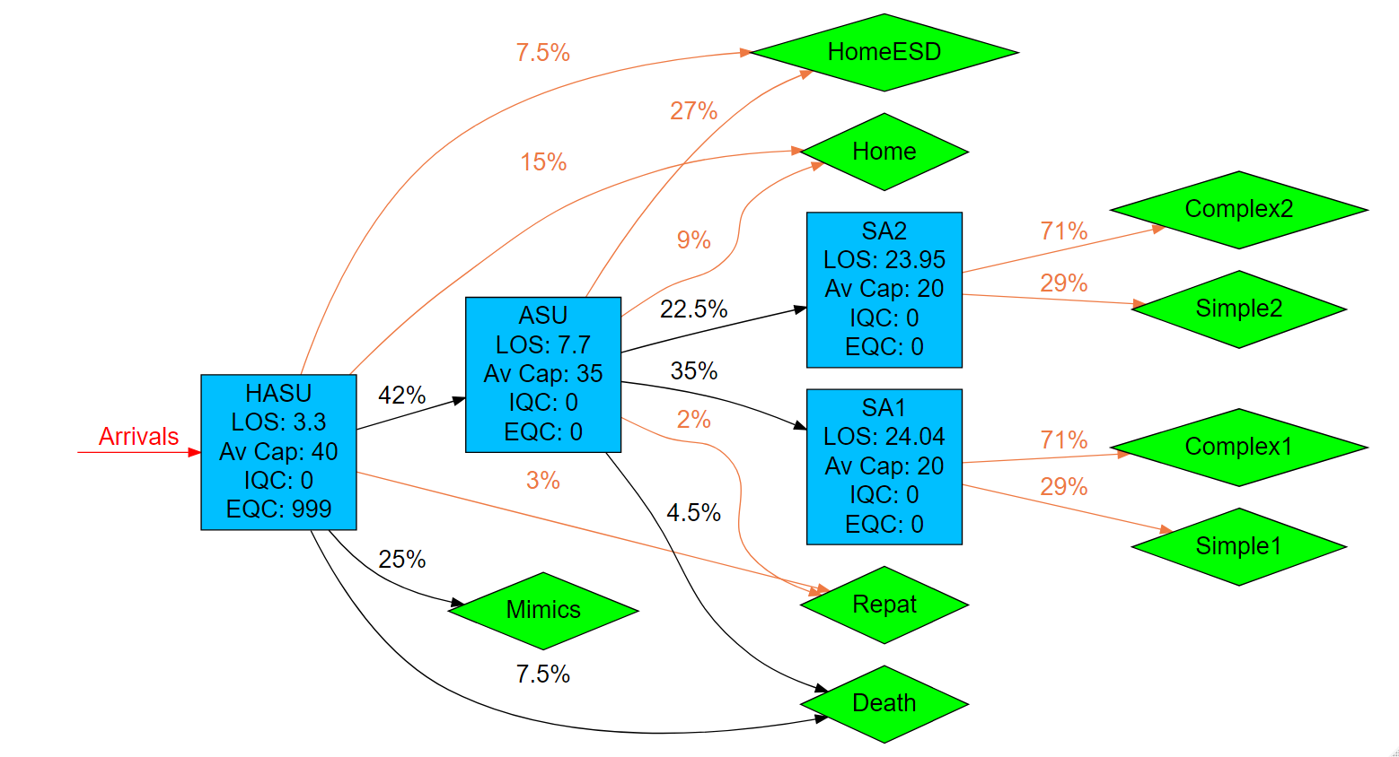

Figure 1

## Input templates

The Pathway Wizard also creates the following two parameter dataframes, which are used to generate the simulation. If the user has entered the data directly into the Pathway Wizard, it can be passed straight to the simulation model without the need for the user to interact directly with these files – but they can be downloaded and saved, then subsequently re-uploaded to PathSimR if the user wishes to run the simulation again without having to re-enter data into the wizard, or if they wish to make changes to specific parameters (e.g. for sensitivity analysis, or “what-if” comparison on the effect of different capacities in given service points).

***Network template***

This template, and extract of which is shown in figure 2, includes transition rates between individual service points and exits, as well as service time parameters and permitted queue lengths for each service point. Note the service points each appear multiple times in the column headers, and the table is truncated at the right.



Figure 2

***Calendar template***

This template, shown in figure 3, includes the arrival schedule (times and associated arrival rates – possibly zero) and the capacity for each service point with a defined capacity and service time.



Figure 3

# Outputs summary

Simulation results for the system described above show that the capacity is insufficient to meet the stated objective of patients arriving to find no “HASU” beds available less than 1% of the time. This appears to be the results of a combination of capacity constraint at “HASU”, and also downstream.

In particular, “HASU” is effectively full (fewer than one bed free) more than 10% of the time (99% occupancy 39.93 against a full capacity of 40), despite average occupancy being only 22.35 patients. There is also a substantial queue at “HASU” (rising to more than 17 patients 10% of the time, with an average queue size of 8.88). Capacity is also severely constrained at both “ASU” and “SA1” which are both effectively full 20% of the time (80% percentile occupancy 34.31 vs full capacity of 35 at “ASU”, and 19.74 vs full capacity of 20 at “SA1”). Note that mean occupancy at “ASU” is 25.79, substantially below its full capacity, while “SA1” is more uniformly full, with an average occupancy of 19.11.

The numerical results are summarised in figure 4 below, and a plot of the results for all service points shown in figure 5.

**Numerical occupancy summary**

|  |  |  |  |  |  |  |  |  |
| --- | --- | --- | --- | --- | --- | --- | --- | --- |
|  | **Occupancy percentile** | | | | | | **Average occupancy** | **Maximum capacity** |
| **node** | **80th** | **85th** | **90th** | **95th** | **99th** | **100th** |  |  |
| **HASU** | 27.85 | 35.7 | 39.27 | 39.64 | 39.93 | 40 | 22.35 | 40 |
| **ASU** | 34.31 | 34.48 | 34.66 | 34.83 | 34.97 | 35 | 25.79 | 35 |
| **SA1** | 19.74 | 19.81 | 19.87 | 19.94 | 19.99 | 20 | 19.11 | 20 |
| **SA2** | 15.24 | 16.06 | 17.1 | 18.58 | 19.75 | 20 | 12.64 | 20 |

Figure 4

**Graphical occupancy summary**

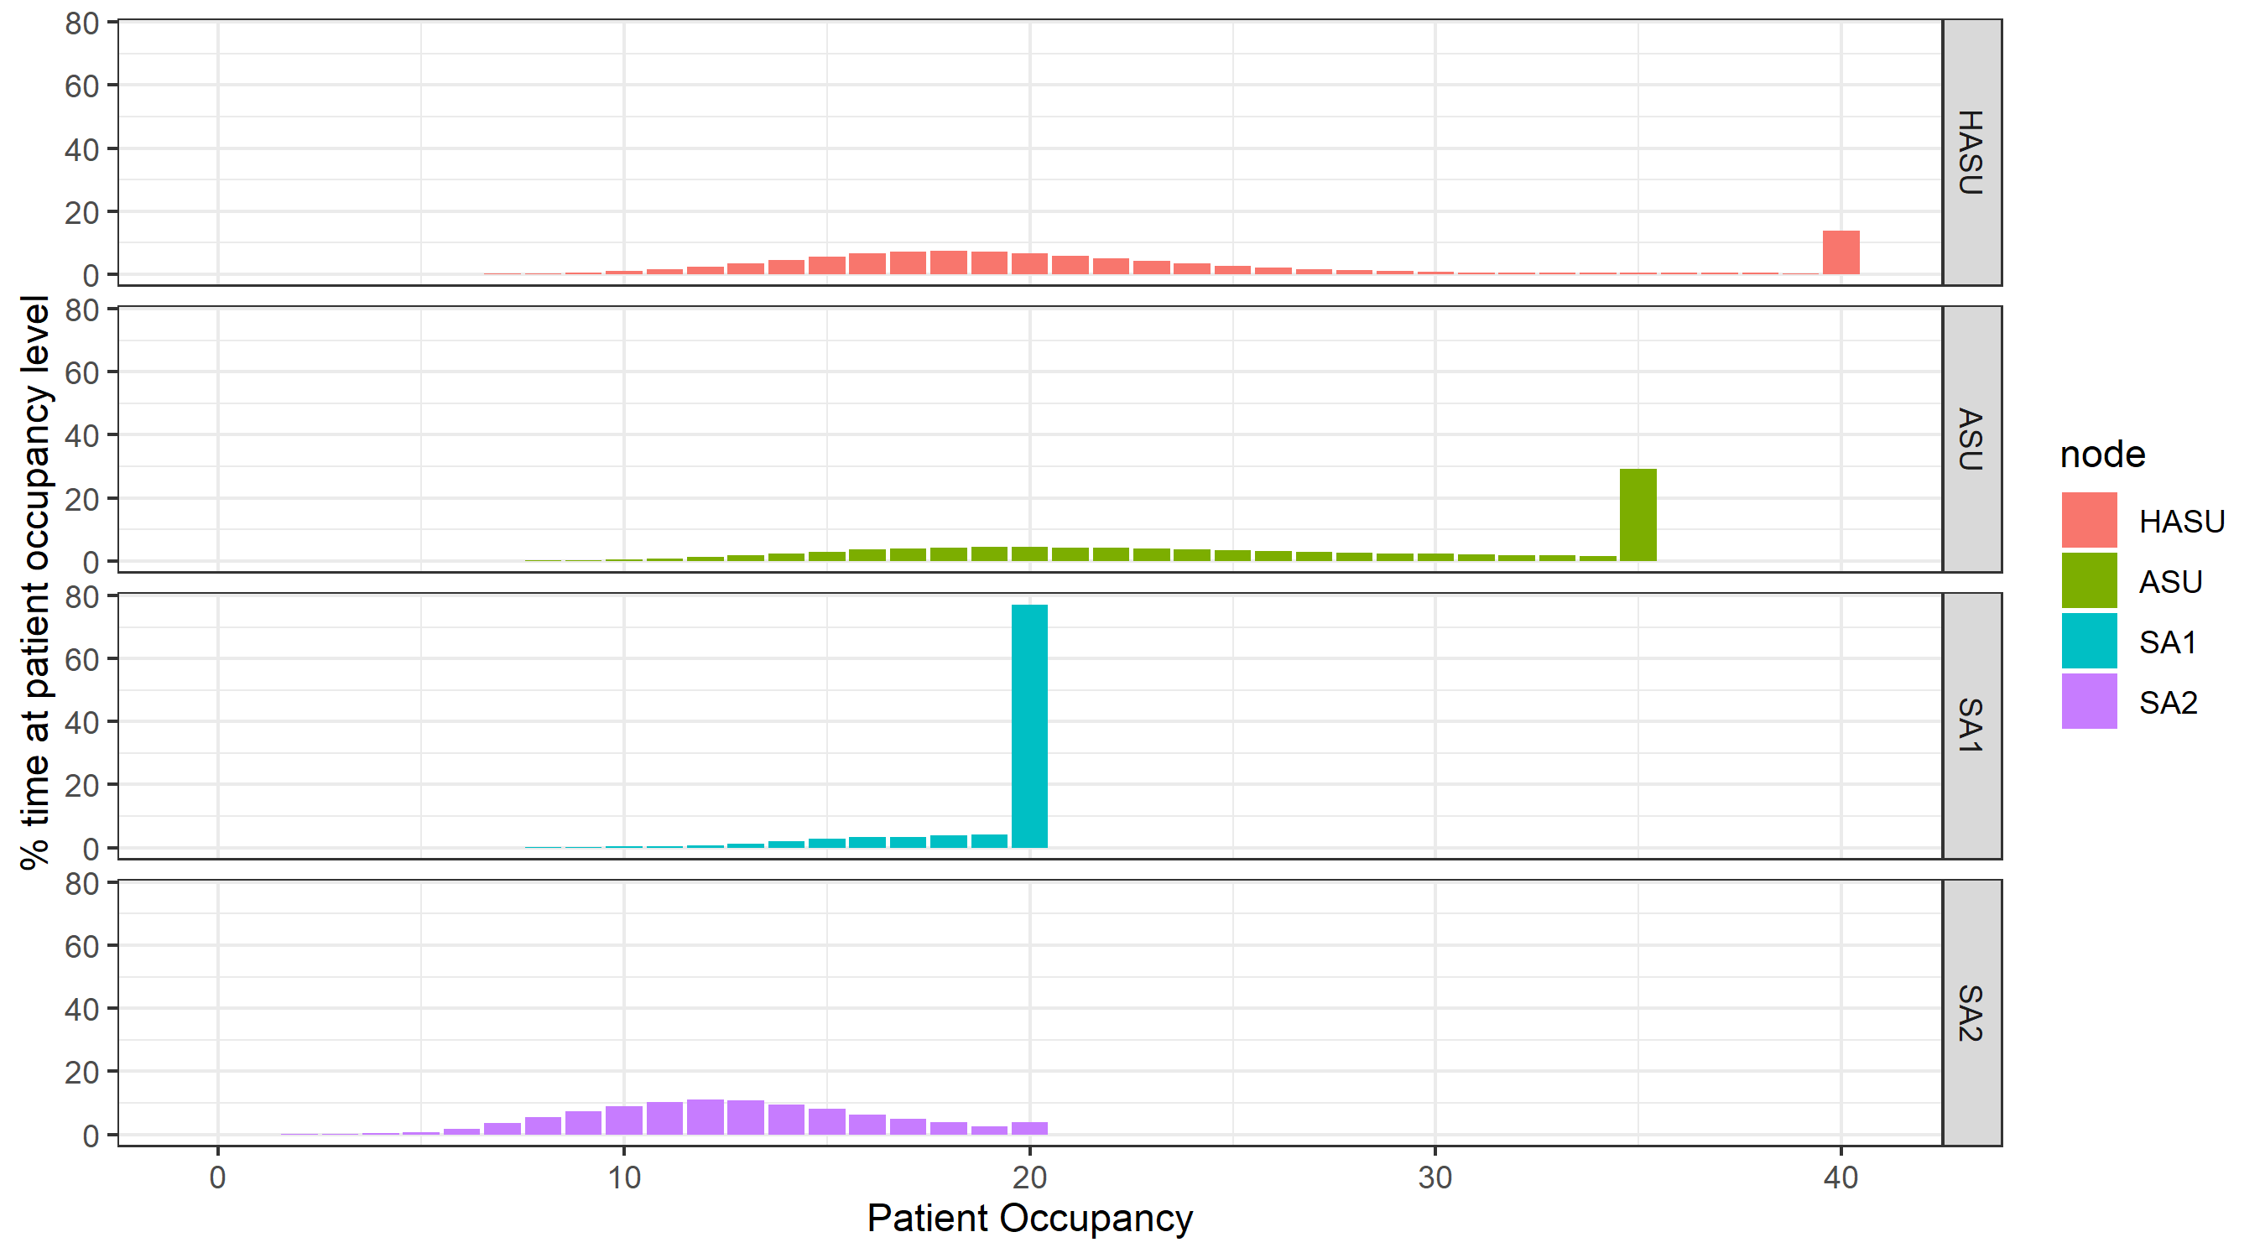

Figure 5

The downstream bottlenecks at “SA1” (and “ASU”) lead to substantial levels of capacity-driven delays at both “HASU” (mean 4.24 patients concurrently delayed, 5% of the time more than 23) and “ASU” (mean 8.12 patients concurrently delayed, 5% of the time more than 20).

1. Richard M. Wood & Ben J. Murch (2019) Modelling capacity along a patient pathway with delays to transfer and discharge, Journal of the Operational Research Society, DOI: [10.1080/01605682.2019.1609885](https://doi.org/10.1080/01605682.2019.1609885)